 | Sinhgad Technical Education Society’s  RMD Sinhgad School of Engineering, Warje, Pune.  Department of Electronics & Telecommunication Engineering.

Name of Student | Aditya Ravindra Ghayal
Division | A
Roll Number | 23
Experiment Title | Cellular System
Marks

 | Sinhgad Technical Education Society’s  RMD Sinhgad School of Engineering, Warje, Pune.  Department of E&TC Engineering | Expt.No.  9
Title | Cellular System

Aim
Determine the number of users that can be supported in a city with given constraints.

Apparatus
PC, Octave

Theory

Traffic in Switching Networks
All the switching exchanges are designed to meet an estimated maximum average simultaneous traffic, usually known as busy hour traffic. Past records of the telephone traffic indicate that even in a busy exchange, not more than 20-30 per cent of the subscribers are active at the same time. Hence, switching systems are designed such that all the resources in a system are treated as common resources and the required resources are allocated to a conversation as long as it lasts. The quantum of common resources is determined based on the estimated busy hour traffic. When the traffic exceeds the limit to which the switching system is designed, a subscriber experiences blocking. A good design generally ensures a low blocking probability.
The traffic in 'a telecommunication network is measured by an internationally accepted unit of traffic intensity known as Erlang (E), named after an illustrious early contributor to traffic theory. A switching resource is said to carry one Erlang of traffic if it is continuously occupied throughout a given period of observation.

The unit of traffic
Traffic intensity or simple traffic is defined as the average number of calls in progress. The unit of traffic is Erlang [E], named after A.K Erlang the Danish pioneer of traffic. On a group of trunks the average number of calls in progress depends on both the number of calls which arrive and their duration.

Holding time
Duration of call is often called its holding time, because its holds a trunk for that time.
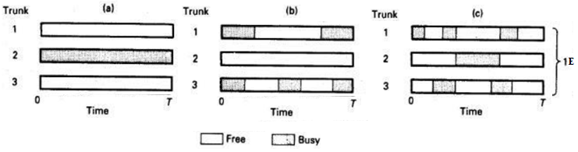
Figure: Examples of 1 Erlang of traffic carried on three trunks
The example in above figure shows how one Erlang of traffic can result from one trunk being busy all of the time, for each of two trunks being busy for half of time or from each of three trunks being busy for one third of the time as in figure a, b and c.
In North America, traffic expressed in terms of hundreds of call seconds per hour (CCS).
1 hour= 3600 seconds
1 Erlang=36CCS
From the definition of the Erlang that the traffic carried by the group of trunks is given by
$$A=\frac{Ch}{T}$$
A= traffic in Erlangs
C= average number of call arrivals during time T
h= average call holding time.
If T=h, then A=C. Thus, number of calls arriving during a period equal to the mean duration of the calls.
Since a single trunk cannot carry more than one call, A<=1, the traffic is a fraction of an Erlang equal to the average propagation of time for which the trunk is busy. This is called the Occupancy of the trunk.

Grade of Service (GOS)
Grade of Service (GOS) is the ratio of lost traffic to offered traffic. Offered traffic is the product of the average number of calls generated by users and the average holding time per call. The actual traffic carried by the network is called the carried traffic. Accordingly, GOS is given by,
$$GOS=\frac{A-A_{0}}{A}$$
where,
A= offered traffic
A0= carried traffic
$A-A_{0}$= lost traffic
So, the smaller the value of grade of service, the better is the service.
GOS is called call congestion or loss probability and the blocking probability is called time congestion.
Delay probability is the probability that a call experiences delay. If the offered load or the input rate of traffic far exceeds the network capacity, then the queue lengths become very large and the calls experience undesirably long delays.
Subscriber viewpoint:
GOS = Call congestion = loss probability
Network viewpoint:
Blocking probability = time congestion

Blocking probability
If the number of trunks is finite and the number of subscribers are more, system faces a problem of congestion.
In this situation of congestion, if new call request arrives, it is rejected or delayed.
If the call request is simply rejected, it is called as last call system. If the call request is delayed by waiting, is a queue. It is called as delayed call system.
Erlang determined grade of service of last call system of finite number of trunks based on following assumptions.
- Pure chance traffic
- Statistical equilibrium
- Full availability
- Calls which face is congestion and gets lost
Full availability means every call request will be served that is every call request can be allocated an outgoing trunk which is free. In practice, this is not possible.
During congestion every new call request is rejected. This is generally observed during busy hours.

 | Sinhgad Technical Education Society’s  RMD Sinhgad School of Engineering, Warje, Pune.  Department of E&TC Engineering | Expt.No.  9
Title | Cellular System
 | Student Worksheet

Problem Statement
Simulate a cellular system with 48 channels per cell and blocking probability of 2%. Assume traffic per user is 0.04 E. What is the number of users that can be supported in a city of 603 km 2 area if cell radios are changed in the steps of 500 m, 700m, 900 m, 1000 m 1200 m and 1500 m.

Calculations
For N = 48 channels and blocking probability P_{B} = 0.02, from Erlang Traffic table the net offered load or supported trafﬁc is given as A = 38.4 E.
Also, since the total trafﬁc $=N×A_{0}$ , we have
Number of users per cell, $N =\frac{A}{A_{0}}=\frac{38.4}{0.02}= 960$
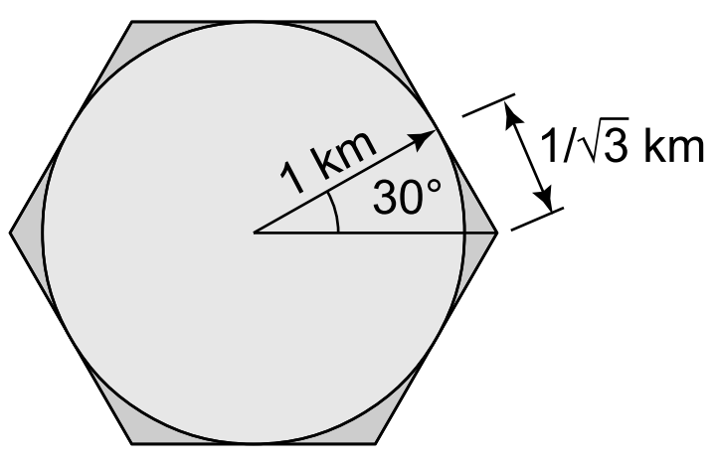
Further, from above figure, the area of a typical hexagonal cell of radius 1 km is given as
$$Cell area = 6 × 1 ×\frac{1}{\sqrt{3}} = 3.46 km^{2}$$
Therefore, the number of cells that are required to cover the entire city is given as
$$Number of cells = \frac{City area}{Cell area} =\frac{603}{3.46} ≈ 174 cells$$
Therefore, the total number of users that can be supported by the cellular provider is given as
$$Number of users supported = Number of cells × Number of users per cell$$
$$Number of users supported ≈ 174 × 960 = 167, 040$$
Thus, approximately 167,040 users can be supported by the cellular service provider in the
given city for the desired blocking probability of 2%.
$$Cell Radius$$ | $$Cell Area = 6×radius(km) ×\tan{{30}^{0}}$$ | $$\# of cells = \frac{city area}{cell area}$$ | $$\# of users supported = \# of cells×\# of users per cell$$
500m
700m
900m
1000m
1200m
1500m

Conclusion
Increasing the geographical area of a cell results in deterioration of number of users to whom service can be provided.

Review Questions
- What is trunking and Grade of Service?
- How does blocking probability affect network traffic?
- What is blocking in mobile communication?
- What is GOS in telecommunication?

 | Sinhgad Technical Education Society’s  RMD Sinhgad School of Engineering, Warje, Pune.  Department of E&TC Engineering | Expt.No.  9
Title | Cellular System
Name
Roll No.

Program
- clc;
- clear all;
- A = 38.4;
- ch = input('Enter number of channels = ');
- pb = input('Enter the blocking probability = ');
- city_area = input('Enter city area in km2 = ');
- radius = input('Enter the multiple values of radius (in km) = ');
- %38.4, supported traffic for 48 channels and pb = 0.02, from Erlang Traffic table
- cell_users = A/pb ;
- cell_area = radius .* (6 * (1/sqrt(3))) ;
- cell_numbers = fix (city_area./cell_area) ;
- supported_users = cell_numbers * cell_users ;
- plot(radius,supported_users);
- plot(radius,supported_users);
- title('Number of Users with 2% Pb');
- xlabel('Radius in km');
- ylabel('supported Users');

Output
Enter number of channels = 48
Enter the blocking probability = 0.02
Enter city area in km2 = 603
Enter the multiple values of radius (in km) = [0.5; 0.7; 0.9; 1; 1.2; 1.5]

Output:

